Smart Study Planner Agent
Observe -> Think -> Act
Project Objective
To design a simple AI agent that creates a weekly study schedule based on student tasks, deadlines, available time, and difficulty level.

1. Project Name: What I Want to Make
The project name is Smart Study Planner Agent.
This project will create a simple AI agent that helps students plan their weekly study schedule. The agent will observe study tasks, think about deadlines and priority, and act by producing a clear Monday-to-Sunday study plan.

2. Real-World Problem Solved by the Project
Many students face difficulty managing assignments, quizzes, exams, and project deadlines at the same time. Without a proper schedule, students often study at the last minute, miss deadlines, or feel stressed because they do not know what to complete first.
The Smart Study Planner Agent solves this problem by automatically organizing study tasks into a weekly schedule. It helps students divide large tasks into smaller sessions, give more time to difficult or important work, and complete tasks before deadlines.
Problem in Student Life | How the Agent Helps
Too many tasks at the same time | Arranges tasks based on deadline and importance
Last-minute study pressure | Creates a weekly plan before the deadline
Confusion about what to study first | Uses priority rules to choose the next task
Large tasks feel difficult | Divides large tasks into smaller study sessions
Poor time management | Matches tasks with available study hours

3. Plan and Implementation Plan
The project will be implemented using a simple rule-based agent. The agent does not need to be complex. The main goal is to show that the agent can observe information, think using priority rules, and act by creating a useful output.

Step 1: Collect User Input
The user enters subjects, tasks, deadlines, available study hours, and difficulty level. Example: Math assignment - Monday - 2 hours - Medium difficulty.

Step 2: Observe the Data
The agent reads all tasks and identifies important information such as the task name, due date, estimated time, and difficulty.

Step 3: Think and Prioritize
The agent ranks tasks using simple rules: closer deadline means higher priority, higher difficulty means more study time, exams are important, and large tasks should be divided into smaller sessions.

Step 4: Create the Weekly Schedule
The agent distributes tasks across the week from Monday to Sunday based on available study time and task priority.

Step 5: Show the Final Output
The agent displays a clear weekly study plan with the task name, day, and study duration.

Sample Input and Output
Task | Deadline | Estimated Time | Difficulty
Math Assignment | Monday | 2 hours | Medium
English Quiz | Wednesday | 1 hour | Easy
Computer Project | Friday | 3 hours | Hard
Business Exam | Sunday | 4 hours | Hard

Day | Study Plan
Monday | Finish Math assignment - 2 hours
Tuesday | Prepare for English quiz - 1 hour
Wednesday | Review English quiz and start Computer project - 1 hour
Thursday | Work on Computer project - 1 hour
Friday | Finish Computer project - 1 hour
Saturday | Study Business exam - 2 hours
Sunday | Final Business exam review - 2 hours

4. System Diagram Using the Agent Repository Design
The system follows a simple repository-style agent design: input data is collected, the agent observes the information, the thinking module prioritizes the tasks, and the action/planning module creates the weekly schedule.

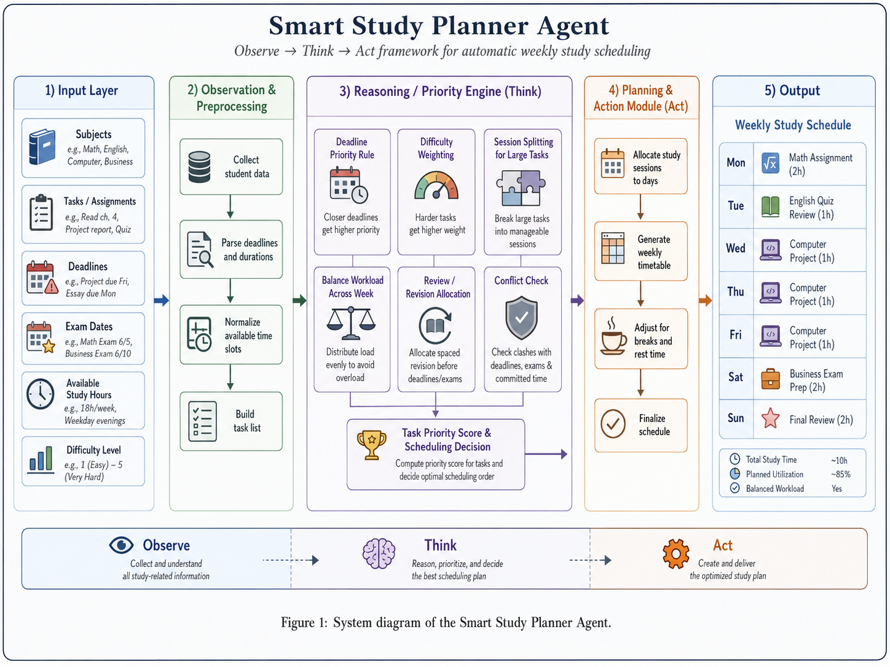
Figure 1: System diagram of the Smart Study Planner Agent

Agent Logic: Observe -> Think -> Act
Observe | Think | Act
Reads the student's tasks, subjects, deadlines, available study hours, and difficulty levels. | Checks which deadlines are closest, which tasks are difficult, and how much time each task needs. | Creates a weekly study schedule and presents it to the student as the final output.

Conclusion
The Smart Study Planner Agent is a useful short AI agent project because it is simple, practical, and easy to demonstrate. It clearly shows the three important agent behaviors: observing information, thinking with rules, and acting to achieve a goal. The final result is a weekly study plan that helps students stay organized, reduce stress, and complete their academic work on time.

